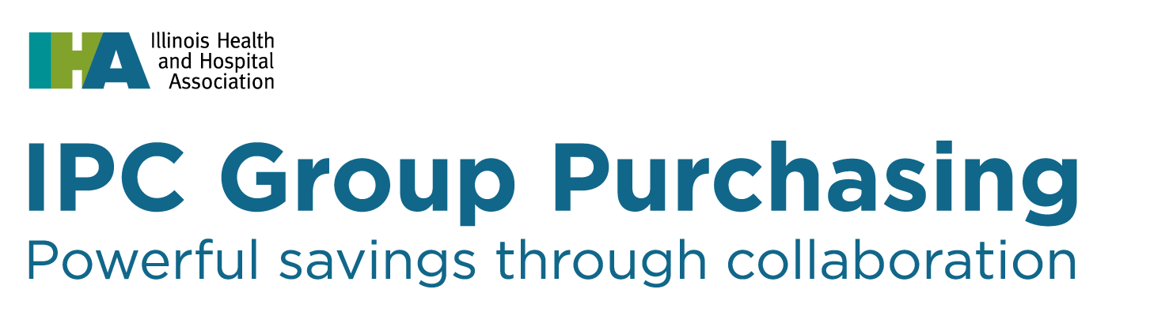

Prospective Supplier Profile

IPC Group Purchasing is a creative collaboration among the Illinois Health and Hospital Association, Premier, Inc., and Capstone Health Alliance that combines the benefits of national pricing from one of the nation’s leading group purchasing organizations with an aggregator – all designed to reduce health care supply chain expenses.

For more information, please visit our website at: http://www.ipcgrouppurchasing.com.

(Please TYPE or PRINT legibly)
Supplier Name: |  |  | Contact Name:
Telephone #: |  | Cell Phone #: |  | E-Mail Address:
Date: | Supplier Website:
Product or Service Description:

Is your product emerging technology? Yes No
If No, who are your competitors?

Is your product or service currently on contract with Premier or Capstone Health Alliance?  Yes No |  |  | Premier Contract #: PP-  Agreement Effective Dates:
Are you currently a supplier of products or services to IPC member facilities?
Yes No
List or attach the IPC member hospitals your company is doing business along with their annual expenditures per product or service category:

List or attach current GPO contracts & their expiration dates.

List or attach current references in the state of Illinois (Acute Care facilities).

Detail your sales representative coverage for the state of Illinois.

Briefly describe the additional value your product or service may bring to IPC membership.

How did you hear of the IPC?

Please return completed form via email or fax to: IPCinfo@team-iha.org / 630.717.4784 (fax)

